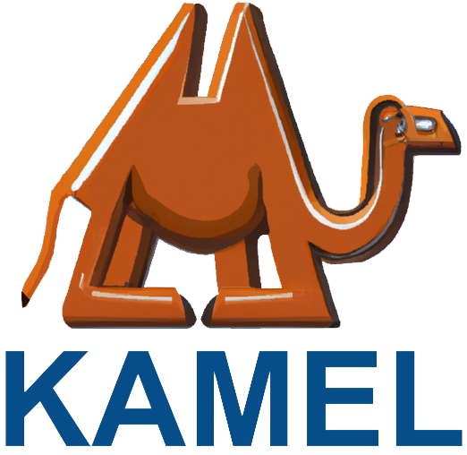
Kamel Grinding Tools Ltd.
————————————————————
Recruitment
All job openings require that you are a Chinese citizen and are fluent in Mandarin.
一、Grinding Tools R&D engineer (1 position)
Salary: Negotiable
【Job Responsibilities】
1. Responsible for collecting and conducting research and analysis of product information and market information, converting them into technical issues or product development directions, and proposing product structure optimization.
2. Responsible for the research and development of the company's new products, including the establishment, optimization, follow-up, and control of technical standards (formula, process procedures, SOP, etc.) from research and development to industrial production.
3. Responsible for the continuous improvement of existing product formulas and processes to improve product performance, reduce costs, and improve production efficiency.
4. Provide guidance on the production process, analyze weak links, and deal with relevant technical issues involved in the production process; be responsible for failure analysis and the formulation and implementation of reasonable solutions during the production process.
5. Support customer technical services (pre-sales, in-sales, and after-sales services), understand product features and customer on-site usage parameters and requirements, and solve product technical problems raised by customers.
6. Responsible for product-related knowledge training for company sales personnel and other ad-hoc work as required.
【Job Requirements】
1. Master's degree or above in a related engineering field.
2. Degree in related majors such as polymer materials, organic synthesis, inorganic non-metallic materials, silicate engineering, abrasives and grinding tools
3. Have 2 years or more experience in product research and development, and be familiar with the product design and development process. Applicants with experience in large manufacturing companies and/or overseas companies will be given priority.
4. Strong understanding of common engineering methods for process improvement such as APQP, FMEA, SPC, and Six Sigma, and demonstrate them in all facets of the manufacturing process.
5. Have strong information collection and analysis capabilities, experience in experimental operations, and technical report writing capabilities.
6. Be proactive, have clear logical thinking, have strong scientific research ability, learning ability, team awareness, coordination, and communication skills, and be able to participate in company-related business trips when required.
二、Grinding Tool Machine Operator (3 Positions)
Salary: Negotiable
【Job Responsibilities】
1. Able to strictly follow the required processing procedures, and skillfully and independently complete product processing and other required production work.
2. Follow the instructions of supervisors and management and independently complete set tasks.
3. Understand the processes related to product processing, production, and packaging.
4. Ability to propose reasonable solutions or recommend appropriate tools and products based on customer needs for special products.
5. Be willing to continue learning, master product knowledge, and improve skills.
6. Be responsible for the hygiene and cleaning in the workshop as well as placement of items and other chores, and follow the 5S process.
【Job Requirements】
1. College degree or above; majors in machinery, materials, and automation are preferred.
2. Have factory-related experience and understand production processes.
3. Be a careful, serious, patient person with a strong sense of responsibility who is dedicated, honest, and down to earth.
4. Good communication and coordination skills, good teamwork skills, able to work while under pressure, and able to offer constructive suggestions on process improvement.
5. Priority will be given to those with experience in tool grinding and material polishing manufacturing.
6. Aged no more than 40 years old
Age requirement: 20-40 years old Function category: General worker/operator
三、Abrasive Technicians (2 positions)
Salary: Negotiable
【Job Responsibilities】
1. Responsible for the work in the alumina production workshop following all the correct process procedures and job responsibilities of this position.
2. Strictly follow various requirements and systems required for production site management.
3. Perform work duties well and complete the assigned production tasks on time.
4. Maintenance of equipment and tools used to prevent unnecessary damage or loss.
5. Comply with the operating procedures and complete the required records fully to ensure safe production.
6. Complete ad-hoc duties as assigned by supervisors or management.
7. Daily completion of the 5S process in the workshop.
8. Proper use of grinding wheels and equipment.
【Job Requirements】
1. Familiar with the alumina production process.
2. Be hard-working and diligent when learning tasks.
3. Strong sense of responsibility and rational thinking.
四、Grinding Tools Sales Engineers (3 Positions)
Salary: Negotiable
【Job Responsibilities】
1. Responsible for the development and business expansion of customers in the abrasives and grinding wheel project industry.
2. Responsible for the promotion of new products and application development of new markets.
3. Responsible for collecting industry competitors and customer information.
4. Management of the entire sales process, including the handling of goods leaving the warehouse, invoicing, and payment collection, etc.
【Job Requirements】
1. Have relevant work experience in the mechanical processing industry.
2. Have sales experience dealing with key account customers.
3. Proficient in driving, minimum C2 driver's license, and able to undertake company-related business trips as required.
五、Warehouse Manager (1 Position)
Salary: Negotiable
【Job Responsibilities】
1. Responsible for the acceptance, storage, placement, packaging, delivery, and other processes of daily materials in the warehouse.
2. Implement and improve warehouse rules and regulations, standardize work processes, improve efficiency, and reduce losses.
3. Use warehousing best practices to manage goods storage locations and propose improvement plans to ensure maximum utilization of the warehouse;
4. Inventory management and stocktaking.
【Job Requirements】
1. Technical secondary school degree or above, familiar with computer office software operation
2. Familiar with warehouse entry and exit operation procedures, and possessing professional knowledge and skills in material storage will be given priority.
3. Positive and hardworking, strong sense of responsibility, cooperative and innovative spirit.
4. Working hours: 8 hours a day (working hours 10:00-19:30, 1.5 hours of rest during the period), Sunday off, occasional overtime (with overtime pay).
5. Food and accommodation included for lunch and dinner
Age requirement: 20-40 years old
六、General Workers/Packers (2 Positions)
Salary: Negotiable
【Job Responsibilities】
1. General warehouse duties including receiving, packaging, and storage of products.
2. Careful, diligent, and proactive work.
3. Follow the 5S process and keep the warehouse organized and tidy.
【Job Requirements】
1. Female prefered
2. 20-40 years old

